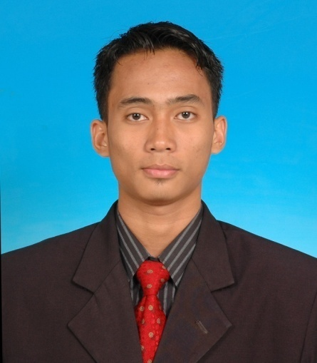**MOHAMMAD AZWANIZAM BIN ZAHARI**

**POST APPLIED FOR :**

**ENGINEER**

|  |  |
| --- | --- |
|  |  |

**Permanent Address :** No. 17, Kampung Dato’ Seri Kamaruddin

Tambahan, 32040 Seri Manjung, Perak

**Mobile No.** : 011-19070574

**Email** : MohammadAzwanizam.BinZahari@flextronics.com

**PERSONAL PARTICULARS**

**Nationality :** Malaysian **Race & Region** : Malay & Islam

**Gender :** Male **Marital Status :** Single

**I/C No. :** 910503-08-5003 **Age :** 25 years

**QUALIFICATION**

**Qualification** : Bachelor of Engineering (Electrical Energy Systems)

**Institute/University** : Universiti Malaysia Perlis (UniMAP), Malaysia

**Duration** : September 2012 - June 2015

**CGPA** : 2.6

**Subjects Taken** : Electric Circuit II, Digital Electronic II, Analog Electronics, Instrumentation and Measurements, Electrical Power Technology, Microcontroller system Design, Signals and Systems, Power System Eng. , Control Systems Eng., Electrical Machines, Electromagnetic Theory, Power System Analysis, Power Electronics I, Communication System Eng. , Electrical Energy System, Electrical Energy Utilization, Power Electronics For Energy System, Power System Operation and Control, Power Electronics Drives, Renewable Energy System, High-voltage Eng.

**Qualification** : Diploma of Electronic Engineering

**Institute/University** : Politeknik Ungku omar (PUO), Malaysia

**Duration**  : July 2009 – May 2012

**CGPA** : 3.41

**Subjects Taken**  : Electrical Technology, System Electronic, Engineering practical, Electrical Technology II, System Electronic II, Engineering Practical II, C++ Programming, C++ Programming II, Management, Telecommunication, Instrument, Audio Visual System, System Microprocessor, Analysis Circuit, System Communication, Control Automation System, Data Communication, Microwave

**WORKING EXPERIENCE**

1. **Company :** Flextronics Technology (Penang) Sdn. Bhd., Malaysia

**Duration :**  10 July 2015 – Present

**Position :** Test Engineer

**Department :** Operations Department

* Assists in equipment modification or upgrading for continuous improvement project.
* Handles the project set-up at test engineering area.
* Test software/hardware improvement.
* Provides production support at test engineering area.
* Failure analysis on customer return and production rejects.
* Evaluates component failures.
* Tests equipment calibration/PM, quotation and evaluating tester.
* In charge for NPI project Gladiator PTX for server Facebook and Google.
* Do the install program for CPLD and FPGA using software Quartus II and Impact.

1. **Company :** MTU Services (M) Sdn. Bhd., Malaysia

**Duration :** 16 June 2014 – 5 September 2014

**Position :** Intern

**Department :** Control and Automation Department

* Service maintenance engine navy and maritime Malaysia ship.
* Service sensors used at the engine.
* Learn advance system what the marine ship using.
* Service generator for marine and petronas genset.
* Service engine and test governor automatic control (GAC) for KTMB locomotive.

1. **Company :** IKE Services (M) Sdn. Bhd., Malaysia

**Duration :** 3July 2012 – 24 August 2012

**Position :** General Worker

**Department :** Electronics and Electrical Department

* Do wiring lamp at marine ship.

1. **Company :** Boustead Naval Shipyard., Malaysia

**Duration :** 29 November 2010 – 29 April 2011

**Position :** Intern

**Department :** Electrical Department

* Wiring for sensor at engine marine ship.
* Doing parameter for setting sensor.
* Learn and do it testing for starter.
* Learn system for using at marine ship.

**COURSES / SEMINARS / WORKSHOPS ATTENDED**

1. Certificate of program telecommunication technology from ERICSSON.
2. Certificate of cabling test technician from Fluke network.
3. Certificate of fiber optic communication technology from Significant technologies Sdn. Bhd.
4. Certificate of participation in ITEX 2012 (23rd International Invention, Innovation & Technology Exhibition).

**REWARD**

1. First place in the final project (Department of electrical engineering).
2. Awarded of Best Project (Ungku Omar Polytechnic,2012).
3. Bronze in ITEX 2012 (23rd International Invention, Innovation & Technology Exhibition).
4. Awarded of Dean List Semester 2, session 2009/2010 (PUO).

SKILLS

**(Proficiency: Advanced – Highly experienced; Intermediate – Familiar with all the basic functionalities;**

**Beginner – Just started using or learning the skill)**

**Computer Skills**

|  |  |
| --- | --- |
| **Skill** | **Proficiency** |
| 1. Programmable Logic Control (PLC) | Intermediate |
| 1. Quartus II (cpld,fpga) | Advanced |
| 1. Impact | Advanced |
| 1. Microsoft Office | Advanced |
| 1. Matlab | Intermediate |
| 1. C++ Programming | Intermediate |
| 1. AutoCAD | Intermediate |
| 1. Proteus | Advanced |

**Language Skills**

|  |  |  |
| --- | --- | --- |
| **Language** | **Spoken** | **Written** |
| 1. Bahasa Malaysia | Advanced | Advanced |
| 1. English | Intermediate | Intermediate |

**Soft Skills**

1. Good analytical and initiatives as well as creative thinking.
2. Flexible and able to work effectively in group.
3. Able to create a work environment that encourages achievement, responsibility and advancement.
4. Able to communicate and writing in English.
5. Can learn new project or activities.

**EXPECTED SALARY**

RM3000

**REFEREE**

Mr Teong aik ooi Dr. Nuriziani Binti Hussin

Manager Senior Lecturer/Academic

Flextronics Technology (Penang) Sdn. Bhd Coordinator, School Of Electrical

Plot 13 Phase 4, Prai Industrial Estate, System Engineering,

13600 Prai, Universiti Malaysia Perlis,02600

Penang Pauh Putra, Perlis, Malaysia.

Tel : 604-5075600 Tel: 019-9500121